Project Plan

Retraction System

Edorado Marine
Dordrecht, The Netherlands

Date : 10-02-2023
Version : 1.6
Status : Final version
Author : Casey Stijlaart

Version

Version | Date | Author(s) | Amendments | Status
1.1 | 07-02-2023 | Casey Stijlaart | 1. Project assignment  - 1.1, 1.2, 1.5  2. Approach and planning  - 2.1 | Incomplete
1.2 | 08-02-2023 | Casey Stijlaart | 1. Project assignment  - 1.3, 1.5  2. Approach and planning  - 2.1.1, 2.2, 2.3, 2.4  3. Project Organization  - 3.1, 3.2, 3.4 | Incomplete
1.3 | 09-02-2023 | Casey Stijlaart | 1. Project Assignment  - 1.4  2. Approach and planning  - 2.4  3. Project Organization  - 3.3 | The first version. Ready for feedback.
1.4 | 10-02-2023 | Casey Stijlaart | 1. Project Assignment | Applied feedback of Peter Meijer
1.5 | 01-03-2023 | Casey Stijlaart |  | Applied feedback from Franco van Gastel
1.6 | 20-03-2023 | Casey Stijlaart |  | Applied feednack from Franco van Gastel

Communication

Version | Date | To
1.3 | 09-02-2023 | Peter Meijer
1.4 | 01-03-2023 | Franco van Gastel
1.5 | 14-03-2023 | Franco van Gastel

Table of Content

1. Project Assignment 4
1.1 Context 4
1.2 Goal of the project and assignment 4
1.3 Scope and preconditions 5
1.4 Finished products 5
1.5 Research questions 6
1.6 Research methods 6
2. Approach and Planning 8
2.1 Approach 8
2.2 Breakdown of the project 8
2.3 Time plan 9
3. Project Organization 10
3.1 Team members 10
3.2 Communication 10
3.3 Test environment 10
3.4 Configuration management 10
4. Finance and Risks 11
4.1 Risks and fallback activities 11

Project Assignment

Context
Edorado Marine is a small start-up company that is developing a powerboat, that is not as damaging to the planet as the current existing powerboats. Besides this main aspect, features will be implemented within the boat that makes them stand out from the crowd. These features are currently not yet common or even exist within any other electric powerboats, and therefore make the Edorado Marine electric powerboat one of a kind. Examples of the implemented features are hydrofoils and the three touch displays that are positioned in the front of the boat.

Since the product is currently still in its developing phase, certain aspects have yet to be tackled or are currently being tackled. One of the parts that have yet to be tackled is the retraction system that works according to the input of the designated display. This part is what I, the intern, will be working on throughout the internship period.

Goal of the project and assignment
Within the boat a retraction system is present. The retraction system is an sub-system within the boat that takes care of of retracting and expanding the hydrofoils, see Figure 1. Retraction system(gif), to get an indiciation on how it operates. Regarding to what hydrofoils are, a hydrofoil is an flat surface that lifts the moving boat.
As of today, the retraction system is not integrated with the UI of the boat. Therefore can only be operated in a ‘simple’ manner by using buttons and flip switches. The reason for not having this feature implemented yet can be explained due to the fact that the company ‘just’ started developing this boat.

Looking at what is wished to be achieved by the end of the internship, it is the goal is to have a retraction system, that works based on the user input of the UI dashboard. The communication between the retraction system and the UI will depend on what is reachable, but it will be either Serial communication or CAN bus.

There is not necessarily an urgency to have this feature integrated. If this feature does end up being fully integrated into the show- and launch boat, this can be showcased at the Yachting Festival (Cannes, France) in September 2023.


Figure 1. Retraction system

Scope and preconditions

The project includes: | The project does not include:
Project Plan (for college and the company) | The Dutch version of documents
System Design | A fully integrated system within the boat (a different intern oversees creating the PCB, so depending on their progress)
Test Report, to verify the behavior of the system. ( for the company)
Internship Report (for college)
The Firmware in C++ (for the company)
Research Document (for the company)

Preconditions – during the project multiple technologies will be used to get to the final deliverable. These technologies include Docker, MPLAB IDE, and GitHub. Besides these technologies, other ones will be used as well to develop the firmware, C++, and the necessary hardware, like the development board.

Finished products
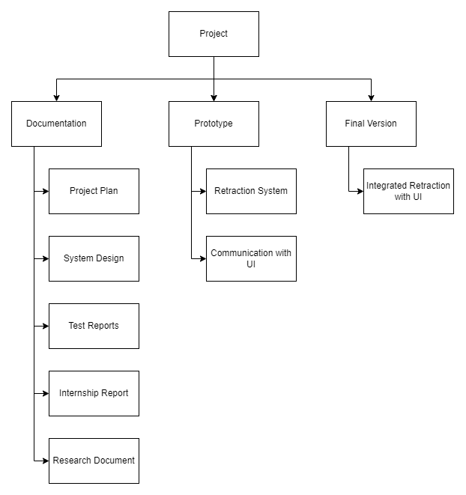
Figure 2. Finished project diagram

Research questions
To get to the final deliverable, multiple aspects first will need to be researched. Each aspect serves a different purpose on how the system should operate. To research the necessary aspects, research questions are created to help guide the research process. There are multiple main questions and multiple sub-questions, the questions are divided regarding specifying how the system should work, which hardware will be used and how they are used.

Specification
- What is the current state of the retraction system?
- What are the system requirements?
- How must the retraction system behave to deliver to correct output?
- Which communication protocol will be used?

Hardware research
- Which hardware will there be used?
  - Which actuators are used within the retraction system?
  - Which development board will be used?
- How will the retraction system be directed?
- How does the retraction system work?
  - How do the used actuators operate within the retraction system?
  - How will the actuators be controlled to deliver the wished-for behavior?
- What are the risks of failures within the retraction system, hardware wise?

Research methods
Each research question requires a different approach and how it will be solved. Therefore, each question will be differentiated and the applicable research method is discussed. Besides the specific research methods per research questions, some research methods apply to non-specific research questions. Meaning that these research methods are used throughout the whole duration of the internship. Each of these ways of reviewing is important to make sure that the current situation aligns with their vision and is up to standards.

Research Question | Strategy | Technique | Steps
What is the current state of the retraction system? | Field  Library | Problem Analysis  Expert Interview | Get in contact with the IT department to discuss the matters. After, the current state must be analyzed.
What are the system requirements? | Field | Interview | Discuss with the IT department their vision and what they want to see at the end of the project. This is regarding the functional and non-functional requirements, and will be worked out in the system design document.
How must the retraction system behave to deliver to correct output? | Workshop  Library  Field | IT Architecture Sketching  Literature Study  Document Analysis  Interview | After inventorying how the system should behave, diagrams will have to be made to visualize the steps that need to be taken. During this, it is important to keep in close contact with a fellow engineer and the internship coach to make sure that you are going in the right direction.
Which communication protocol will be used? | Field | Interview | Based on further progress within the company and its milestones, an interview will need to occur to determine the communication protocol.
Which hardware will there be used?  - Which actuators are used within the retraction system?  - Which development board will be used? | Library | Expert Interview | The other discipline, hardware, should be contacted to discuss the matter.
How will the retraction system be directed? | Field  Workshop | Interview  Brainstorm | Keep in close contact with the embedded engineer to keep track of the current situation and their vision. Brainstorm with them on how the current situation can be approached and what the solution is.
How does the retraction system work?  - How do the used actuators operate within the retraction system?  - How will the actuators be controlled to deliver the wished-for behavior? | Library  Field  Workshop  Lab | Literature Study  Document Analysis  Prototyping  Component Test  Community Research | Based upon the hardware, there will need to be dived into their specifications on how they work, how to approach them, and testing the components and theories.
Table 1. Research methods per research question

Approach and Planning

Approach
Throughout the internship, the scrum method is used. Meaning that there are sprints to keep track of the current process and what is next. Each sprint will last two weeks, within these two weeks there will be a meeting on the first day to discuss what the plan is for the upcoming two weeks and on the last day there will be a meeting to present our work of the past sprint and if applicable, a demo will be given. Besides these two meetings, there are daily stand-ups in the morning. During those stand-ups, there will be discussed what we did the previous day, current issues and the plan for that day.

2.1.1 Test approach
Testing the created software can be done in multiple ways. The most important way will be by using docker to simulate the boat. The company has already set up docker with its necessities, like data from previous test rides of the boat. Besides using docker, another way that the testing can occur is that at the end, if the boat is ready, the software can be implemented and showcased in the real world. Lastly, there can also be made use of any form of unit testing to verify software behavior and keep track on if it preforms as whished for.

Breakdown of the project
The project is divided into 4 different phases, each phase serves its purpose. The phases help to guide you through the entire project and make sure you are staying on track and have a clear overview of what is going on.

Analysis and problem definition:
During the first phase, the most important aspect is to get familiar with the new environment. To define the problem, find possible solutions and make a concrete plan. The plan will be throughout the other phases as well, to make sure that the final project aligns with the client’s wishes.

Design
During the second phase, the focus is moved to the designing part of the system. The most important part is to map out the architecture with the help of for example diagrams, such as flow charts and state diagrams.

Realization
During this third phase, the implementation of all the gained knowledge from the previous phase is put into practice. The software will be created and tested. This will be a continuous cycle until the planned result is delivered.

Evaluation
The last phase is focused on showcasing what has been done throughout all the phases. A demonstration of the final product will take place, simulated, and besides will be evaluated on how it is performing and how the overall process of the project went.

Time plan
The time plan will be roughly sketched out since it can be changed during the internship based upon review or change of circumstances.

Phasing | Start Date |  |  | End Date | Tasks
Sprint 0 | 06-02-2023 |  |  | 17-02-2023 | Get familiar with the company and its environment, create the project plan, and research the hardware.
Sprint 1 | 20-02-2023 |  |  | 03-03-2023 | Research and analyze the current problem, the solutions, and its requirements. Come up with a concrete plan.
Sprint 2 | 06-03-2023 |  |  | 17-02-2023 | Continue concrete plan and design the plan
Sprint 3 |  | 20-03-2023 | 31-03-2023 |  | Continue the design of the concrete plan and start testing with the hardware.
Sprint 4 |  | 03-04-2023 | 14-04-2023 |  | Start implementing the plan.
Sprint 5 |  | 17-04-2023 | 28-04-2023 |  | Implement and test the solution.
Sprint 6 |  | 01-05-2023 | 12-05-2023 |  | Implement and test the solution.
Sprint 7 |  | 15-05-2023 | 26-05-2023 |  | Finalize the implementation and testing. Summarize the testing in the testing document.
Sprint 8 |  | 29-05-2023 | 09-06-2023 |  | Finalize all the necessary documentation.
Finalization |  | 12-06-2023 | 23-06-2023 |  | Finalize the project and prepare for the demonstration.
Table 2. Rough time plan per sprint
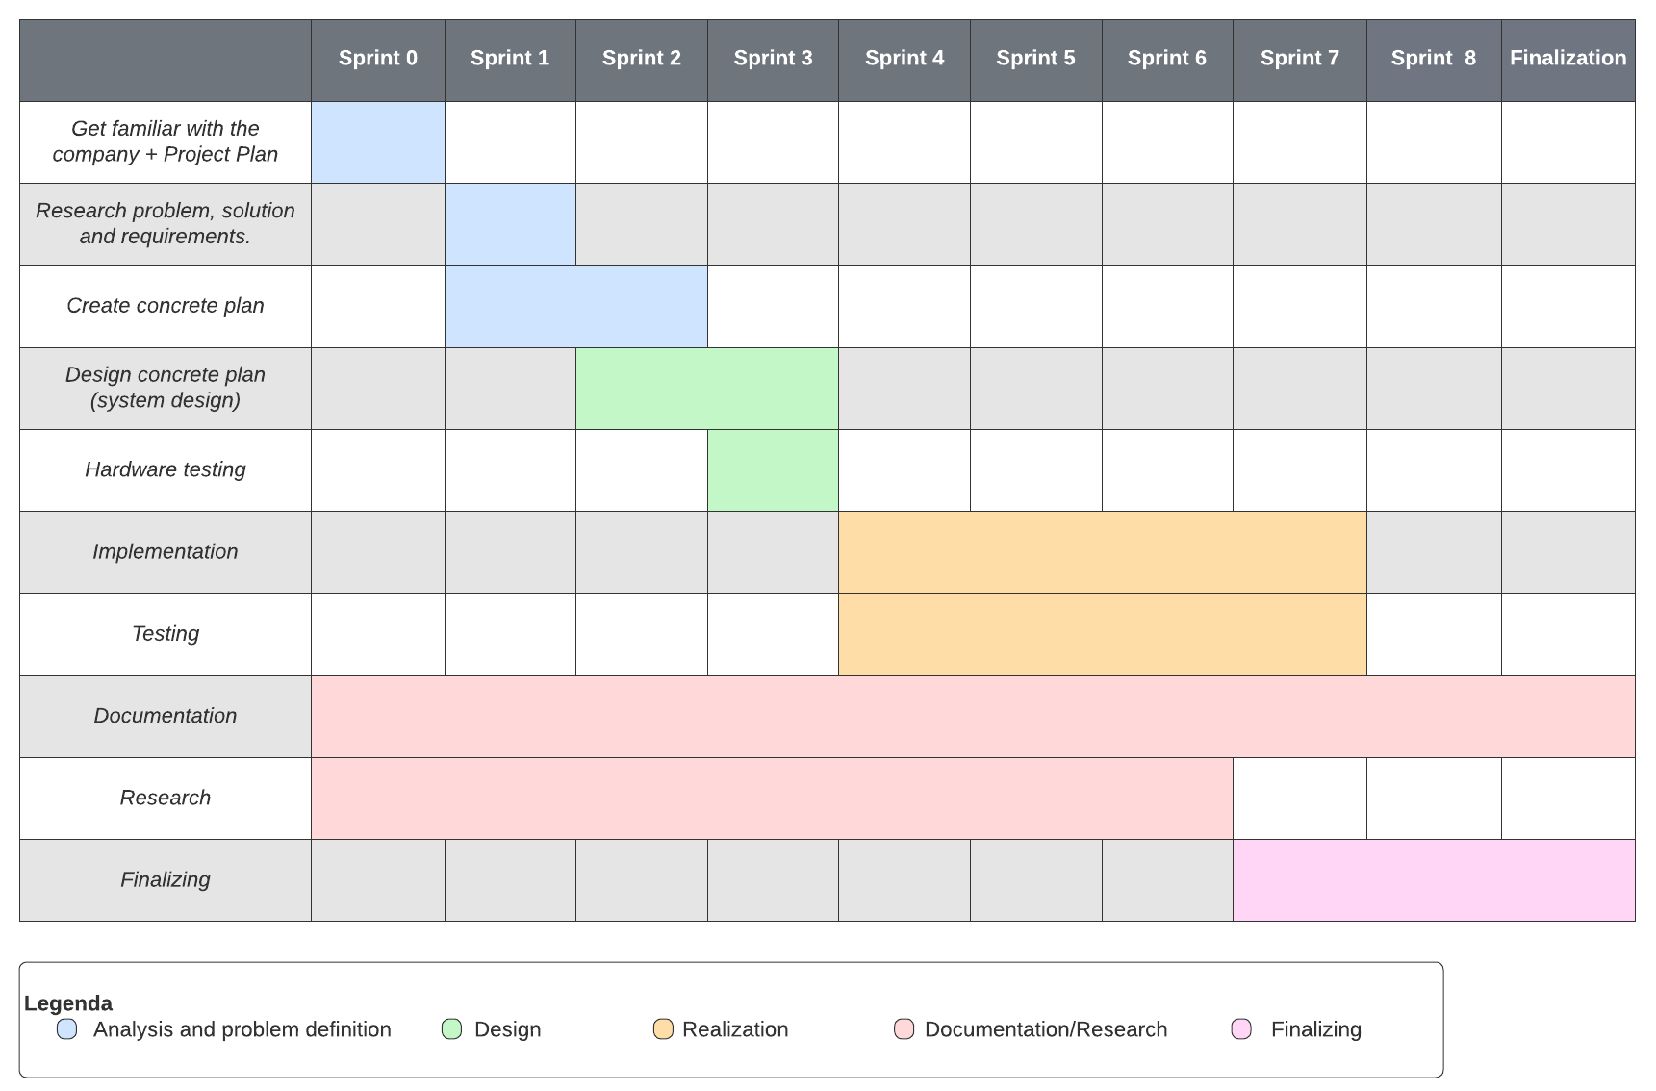
Figure 3. Rough time plan Gantt Chart

Project Organization

Team members
Name + Phone + e-mail | Abbr. | Role/tasks | Availability
Peter Meijer  +31 6 54383476  Peter@edoradomarine.com | P.M. | UI program manager and Team lead | 40 hours per week
Franco van Gastel  +31 6 30070076  F.vanGastel@fontys.nl | F.G. | College Internship Coach | -
Angel Hadzhiev  Angel@edoradomarine.com | A.H. | Full-time worker, Front-End Software Engineer, Scrum master | 40 hours per week
Kai Harten  Kai@edoradomarine.com | K.H. | Full-time worker, Embedded Software Engineer | 40 hours per week
Casey Stijlaart  +31 6 52684033  C.stijlaart@student.fontys.nl | C.S. | Internship Student | 32 – 40 hours a week
Table 3. Team members

Communication
The communication between the company and its members takes place in different ways. The most important way is Skype for daily meetings. When communication outside of these meetings takes place, it is mainly through Slack. Besides these two forms of communication, there is also a form of communication that takes place at least once a week, this is done through physical meetings. The last ways of communication are through email and WhatsApp for the team members that do not use the platform Slack or Skype.

Regarding communication with the college internship coach, this will mostly take place through email, canvas, and MS Teams meetings.

Test environment
Within the team, there is made use of continuous integration testing. For every adjustment, the project is tested in the most suitable way. This testing can be done through, for example, the CI/CD environment, Unit testing and the Docker simulation.

Configuration management
Currently, there are multiple places on which the archiving takes place, including GitHub and Dropbox. Each of these serves its purpose. Dropbox is mainly used to keep track of important documents, such as Project Proposals, Project Plans, and Internship Agreements.

GitHub is the platform that is used to have version control. Besides this, GitHub is used for its workflow as well. GitHub has many different tools to help keep track of milestones, issues, reviews and detecting problems through the CI/CD pipeline. The way branching will work, is by creating a new branch for each issue. Ones the implementation is finished, the branch will have to pass the CI/CD pipeline, making sure there are no errors. After the passing of the pipeline, the branch is up for review. After other members review the work and found problems are resolved, the branch can be merged into the main branch.

Finance and Risks

Risks and fallback activities
Risk | Prevention activities included in the plan | Fall-back Activities
Running out of time. | Make a concrete plan with margins. Planning a bit more time for each phase can help to get behind when problems do occur. | Discuss with internship coaches where to go from now.
Absence of a team member. | Have clear communication on the current situation. And if the absences of a team member take too long, direct action can be taken. | Contact a different team member for the needed help.
Miscommunication. | Be sure to attend the meetings and communicate the current progress and what the plans are. If something doesn’t line up, this can be discussed right away. | Make use of the different communication channels, and if necessary, meetings to get back on the same page. Besides that, the GitHub version control can be used to revert any changes that were made but not wished for.
Hardware issues. | Plan ahead making sure that everything will be there on time and if issues do occur contact the right person right away. | Communicate the problems with the team and find a solution on how it can be solved. In the meantime, documentation can be picked up.
Late change in requirements.. | Keep in close touch with the project lead, to keep track of what’s going on and to get an hint of changes. | Discuss what is feasible and/or of the change in requirements is truly necessary.
Software not up to their standards. | Have frequent code reviews to keep track of how your code fits into their standards. | Discuss the situation and find possible solutions on how to make it up to their standards.
Unplanned additions or work that are added to the work load. | Keep in close touch with project lead, to keep track of how the project is coming along and the wiggle room of additions is. | Come to an altermatum with the project lead to make sure both parties do not suffer any consequences.
Table 4. Risks and solutions

